Version Control

Samuel Cooke – s251388

Repository Link
Link: https://github.com/s251388/AIE-2.1.1-Print-Array.git
Screenshot:
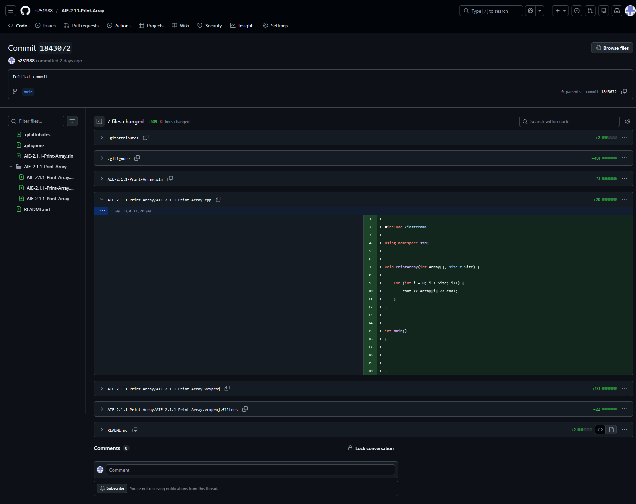
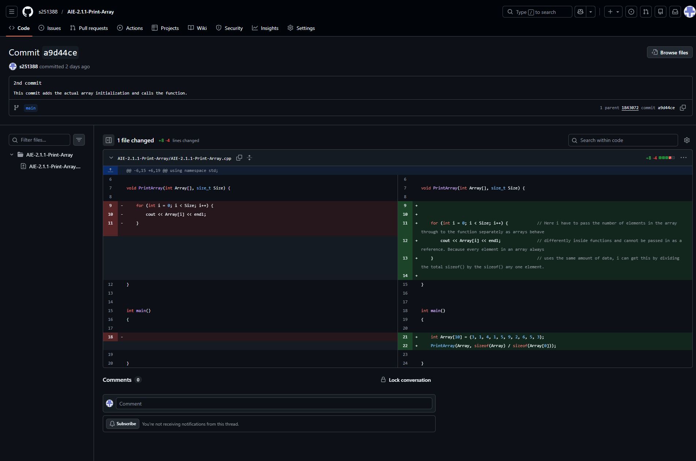

Resources:
- N/A, random knowledge from other projects

Weaknesses
Write a list of personal weaknesses regarding version control and ways you could resolve these weaknesses. (100 - 300 words).
I’m still having trouble fleshing out my own consistent “style” with writing code.

